## Export Manifest Tool

The Export Manifest Tool allows you to create manifest documents based on one or more traffic control plans, then print or export to a range of formats: PDF, Text, CSV, XML and JSON. Access the export tool by right clicking on a **Manifest Box**, or via **File** > **Export** > **Batch Export** > **Export batch manifest…**

Step 1: - Right click on Manifest and select **Export manifest…**

![Right_click_manifest_export](./assets/Right_click_manifest_export.png)

Step 2: - Order manifest items (by name, by value or custom/manually) - Set the units - Set document header (and optional custom description) - Select export format

![Manifest_export](./assets/Manifest_export.png)

And this is an example of exported manifest to PDF

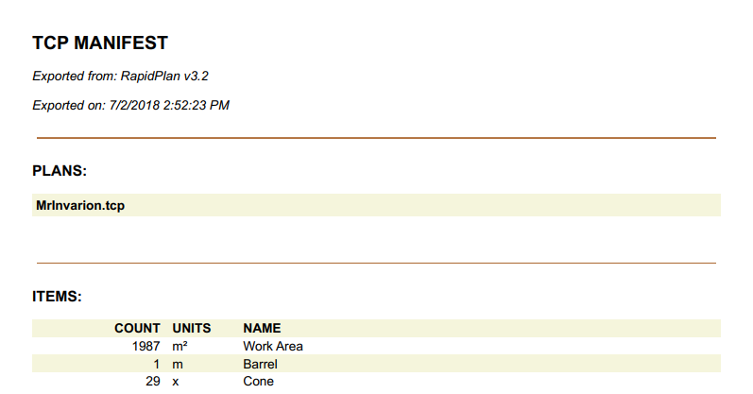

Manifest_pdf_example